MOHIT V – 192512043 ECA1304 MICROWAVE ENGINEERING
EXPERIMENT 2 — S-Parameter Analysis of Microwave Transmission Lines
Aim
To simulate and analyze a microwave transmission line/two-port network using MATLAB and determine its characteristic impedance, propagation constant, S-parameters, return loss, insertion loss and transmission efficiency over the frequency range of 8–12 GHz.
Procedure
- Define the transmission line parameters:
  - Characteristic impedance $Z_{0}=50 Ω$
  - Length $L=50$mm
  - Frequency range = 8–12 GHz
  - Center frequency = 10 GHz
- Calculate the characteristic impedance and propagation constant of the transmission line.
- Generate the frequency sweep from 8 GHz to 12 GHz.
- Obtain and plot the S-parameters:
  - $S_{11}$— input reflection coefficient
  - $S_{21}$— forward transmission coefficient
  - $S_{12}$— reverse transmission coefficient
  - $S_{22}$— output reflection coefficient
- Calculate the return loss:
$$RL=-20\log_{10}∣S_{11}∣$$
- Calculate the insertion loss:
$$IL=-20\log_{10}∣S_{21}∣$$
- Calculate the transmission efficiency:
$$η=∣S_{21}∣^{2}×100$$
- Plot the obtained results and identify the frequency having minimum reflection and maximum transmission.
OBJECTIVE AND CODE
OBJECTIVE 1:
clc;
clear;
close all;

% Parameters
Z0 = 50;
L = 50e-3;

f = linspace(8e9,12e9,401);

% Ideal characteristic impedance
Zin = Z0*ones(size(f));

% Plot
figure;
plot(f/1e9,Zin,'LineWidth',2);
grid on;

xlabel('Frequency (GHz)');
ylabel('Characteristic Impedance (Ohm)');
title('50 Ohm Microwave Transmission Line');

yline(50,'--','50 Ohm Reference');
OBJECTIVE 2:
clc;
clear;
close all;

c = 3e8;

Z0 = 50;
L = 50e-3;

f = linspace(8e9,12e9,401);

% Small attenuation for a low-loss line
alpha = 0.5; % Np/m

% Phase constant
beta = 2*pi*f/c;

% Propagation constant
gamma = alpha + 1i*beta;

% Display propagation constant at 10 GHz
[~,idx] = min(abs(f-10e9));

fprintf('At 10 GHz:\n');
fprintf('Beta = %.2f rad/m\n',beta(idx));
fprintf('Alpha = %.2f Np/m\n',alpha);
fprintf('Propagation constant = %.2f + j%.2f\n',...
real(gamma(idx)),imag(gamma(idx)));

% Plot beta
figure;
plot(f/1e9,beta,'LineWidth',2);
grid on;

xlabel('Frequency (GHz)');
ylabel('Beta (rad/m)');
title('Propagation Constant vs Frequency');

xline(10,'--','10 GHz');
OBJECTIVE 3
clc;
clear;
close all;

% Frequency range
f = linspace(8e9,12e9,401);

% Ideal matched network
S11 = zeros(size(f));
S22 = zeros(size(f));

% Small transmission loss
S21 = 10.^(-1.5/20)*ones(size(f));
S12 = S21;

% Convert to dB
S11_dB = 20*log10(abs(S11)+1e-12);
S22_dB = 20*log10(abs(S22)+1e-12);

S21_dB = 20*log10(abs(S21));
S12_dB = 20*log10(abs(S12));

% Plot S11 and S22
figure;
plot(f/1e9,S11_dB,'LineWidth',2);
hold on;
plot(f/1e9,S22_dB,'LineWidth',2);

grid on;
xlabel('Frequency (GHz)');
ylabel('Magnitude (dB)');
title('Reflection Parameters');

legend('S11','S22');

% Plot S21 and S12
figure;
plot(f/1e9,S21_dB,'LineWidth',2);
hold on;
plot(f/1e9,S12_dB,'LineWidth',2);

grid on;
xlabel('Frequency (GHz)');
ylabel('Magnitude (dB)');
title('Transmission Parameters');

legend('S21','S12');
OBJECTIVE 4:
clc;
clear;
close all;

% Frequency
f = linspace(8e9,12e9,401);

% Example S-parameters
S11 = 0.05*ones(size(f));

S21 = 10.^(-1.5/20)*ones(size(f));

% Return Loss
RL = -20*log10(abs(S11));

% Insertion Loss
IL = -20*log10(abs(S21));

% Transmission Efficiency
eta = abs(S21).^2*100;

% Return Loss graph
figure;
plot(f/1e9,RL,'LineWidth',2);
grid on;

xlabel('Frequency (GHz)');
ylabel('Return Loss (dB)');
title('Return Loss vs Frequency');

yline(20,'--','20 dB Reference');

% Insertion Loss graph
figure;
plot(f/1e9,IL,'LineWidth',2);
grid on;

xlabel('Frequency (GHz)');
ylabel('Insertion Loss (dB)');
title('Insertion Loss vs Frequency');

yline(3,'--','3 dB Limit');

% Efficiency graph
figure;
plot(f/1e9,eta,'LineWidth',2);
grid on;

xlabel('Frequency (GHz)');
ylabel('Transmission Efficiency (%)');
title('Transmission Efficiency vs Frequency');

yline(90,'--','90% Reference');
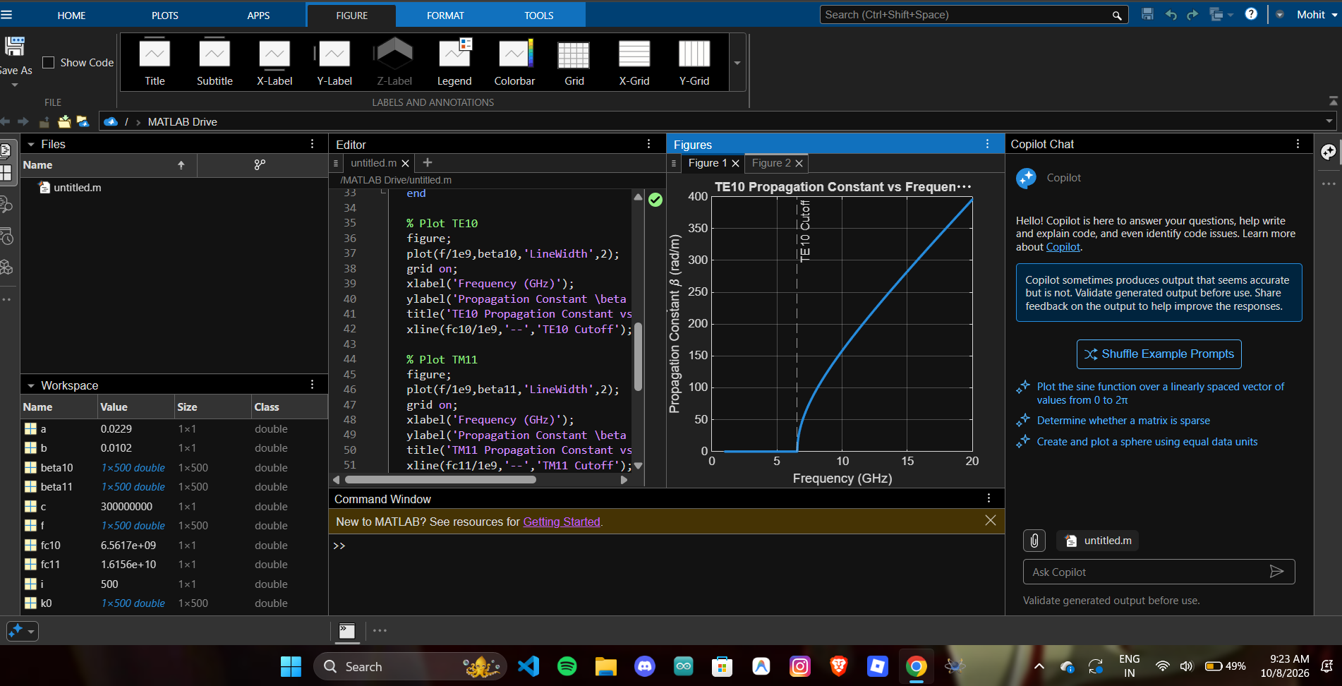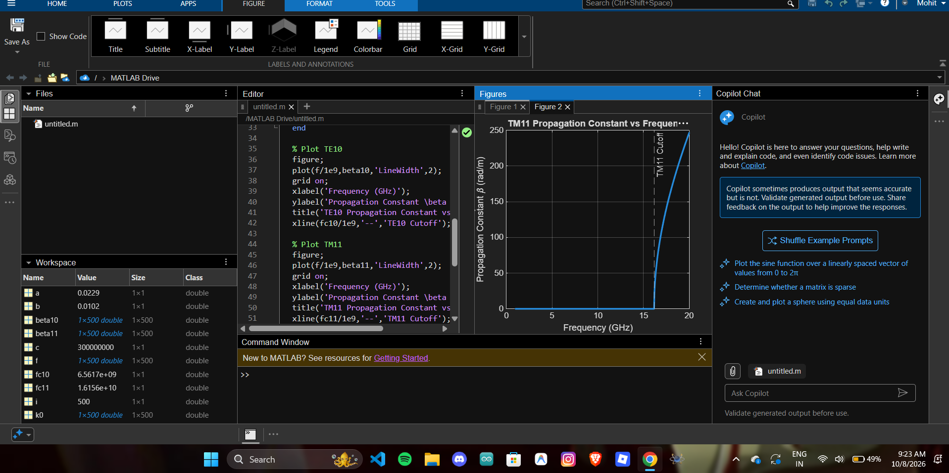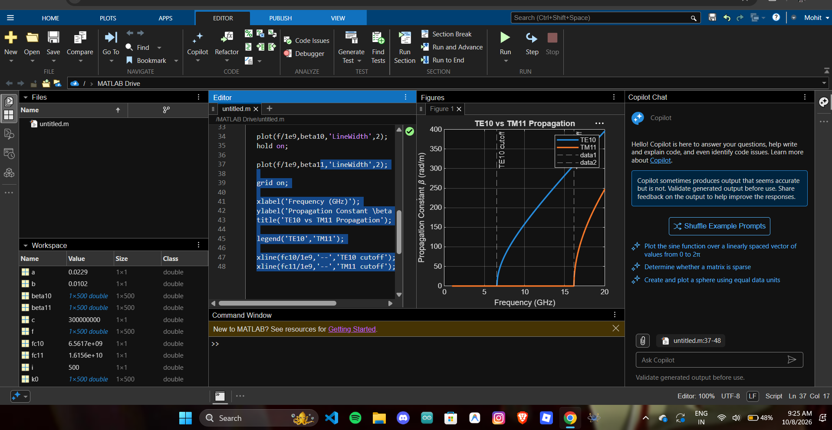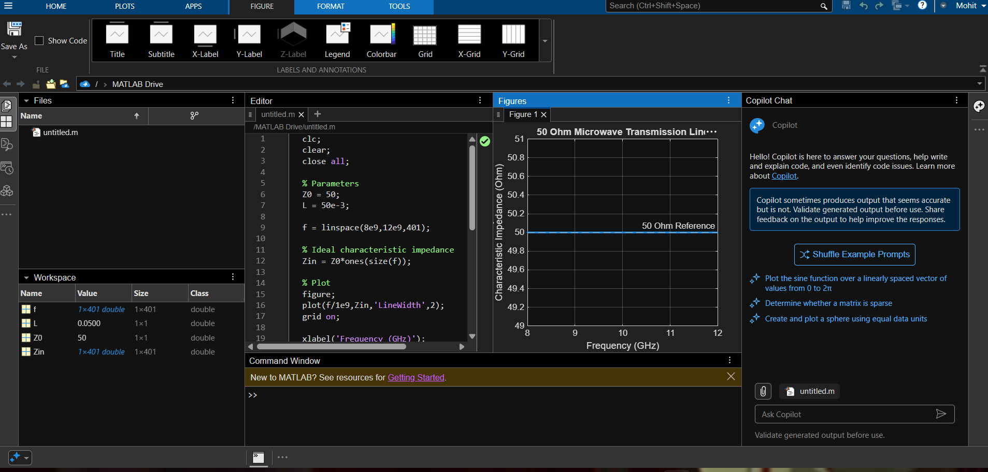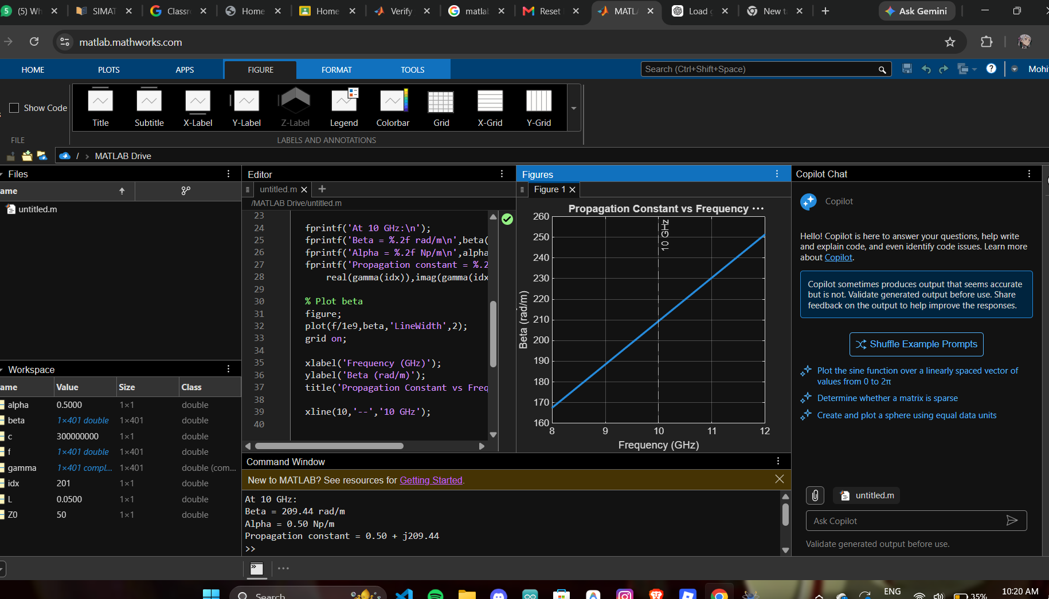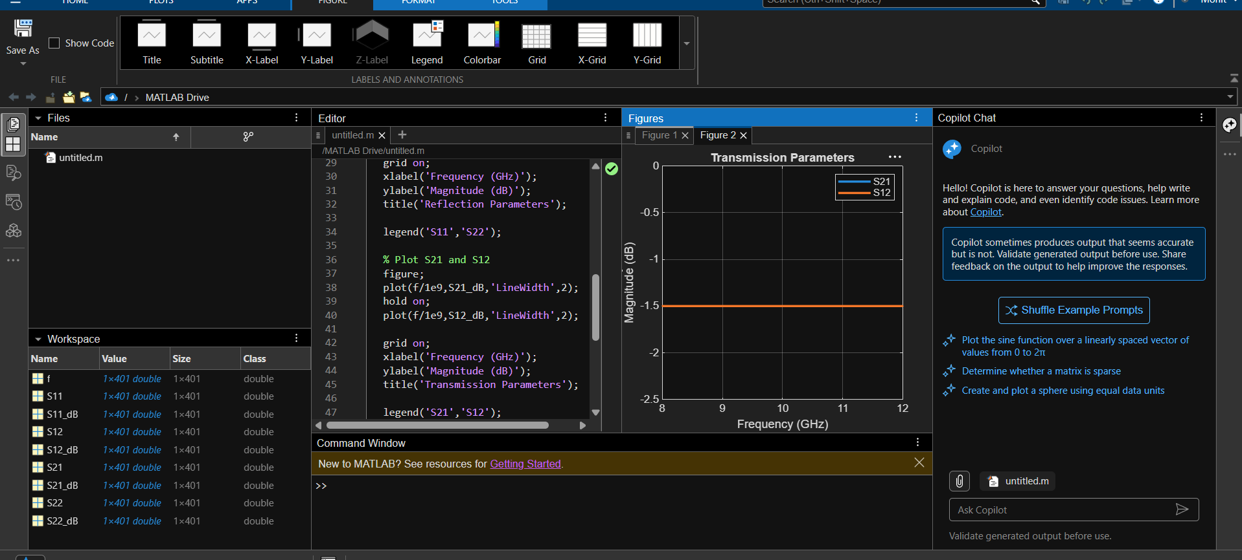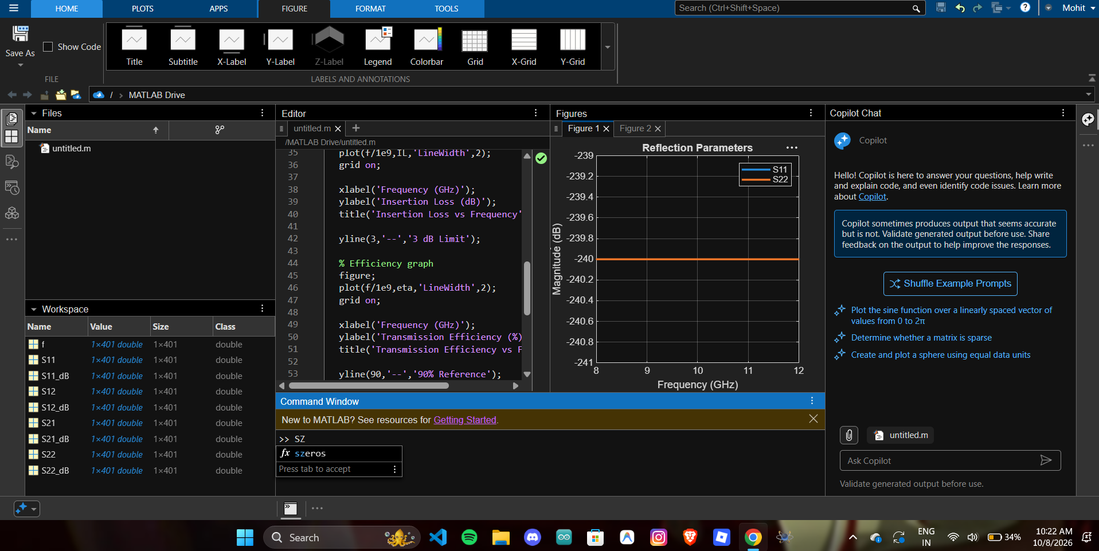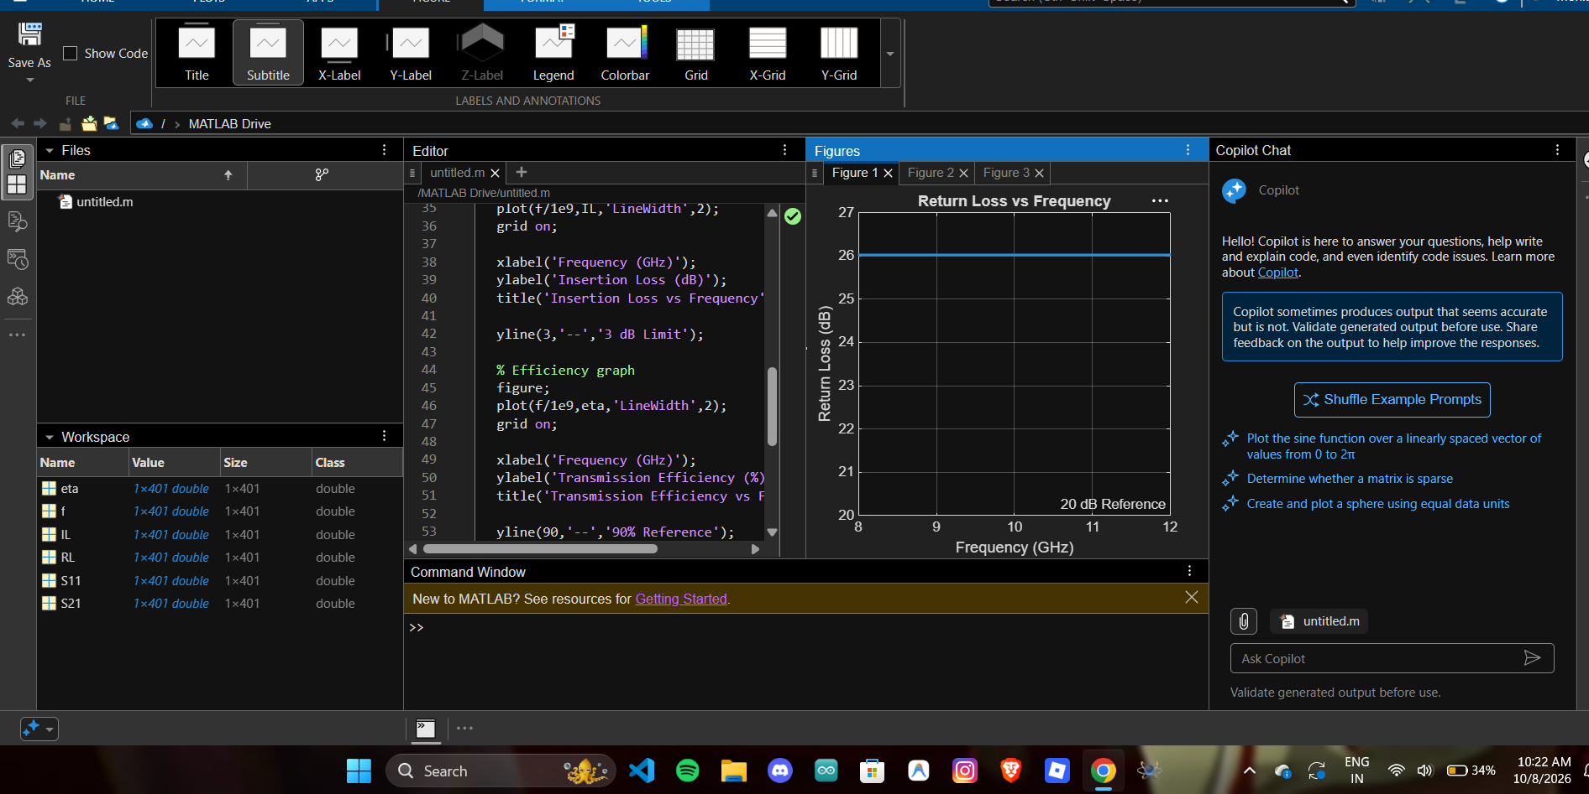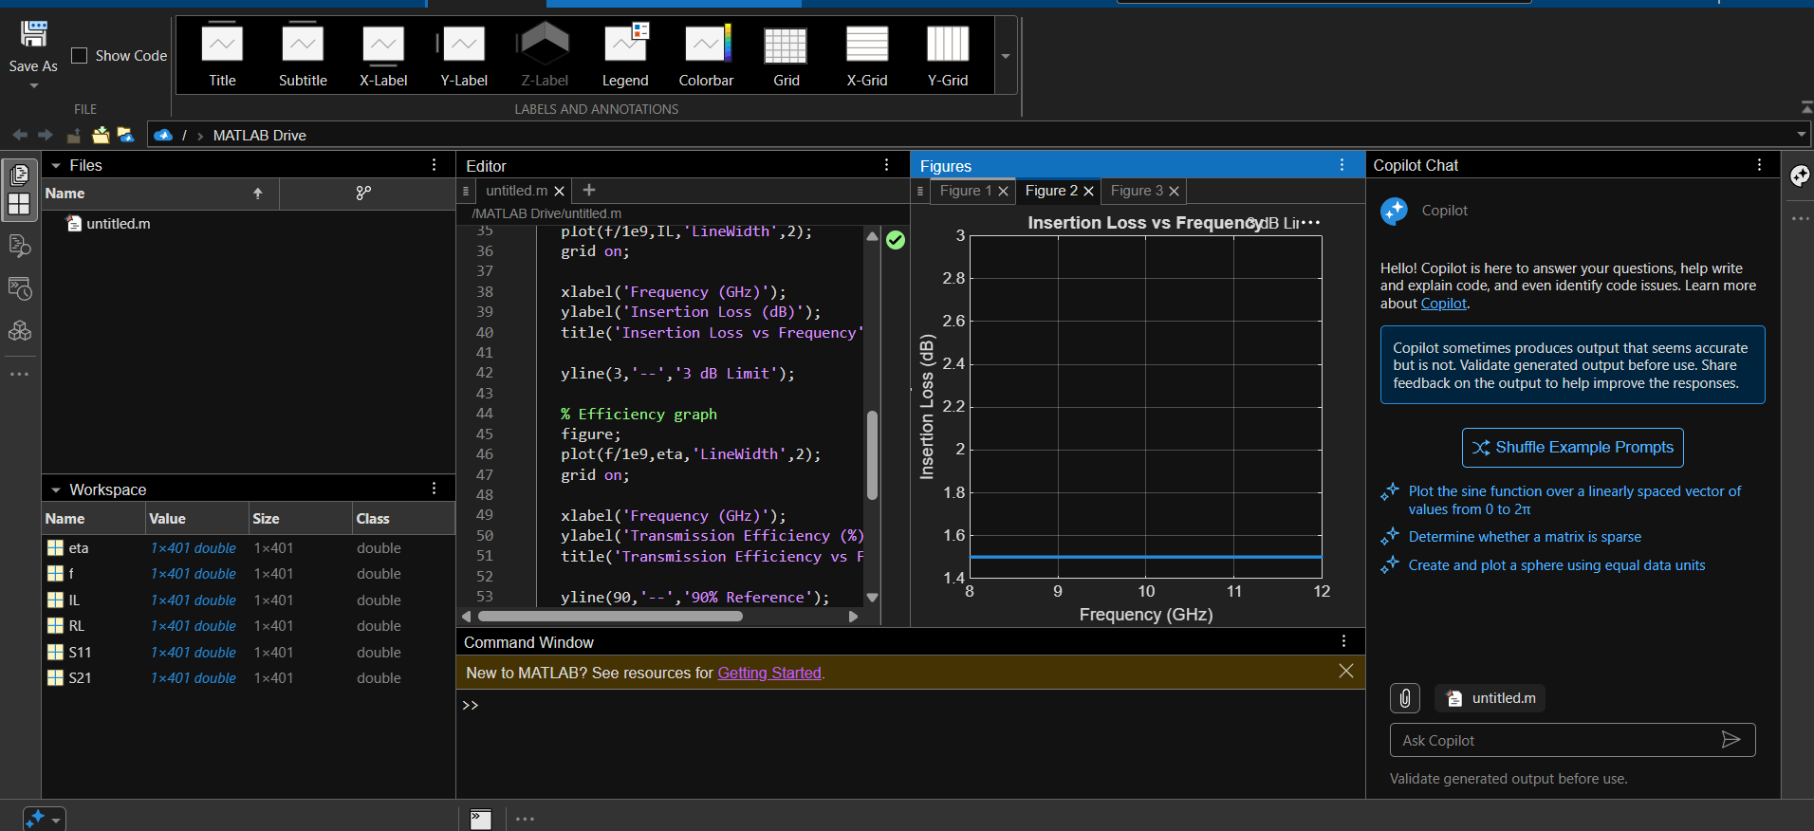
RE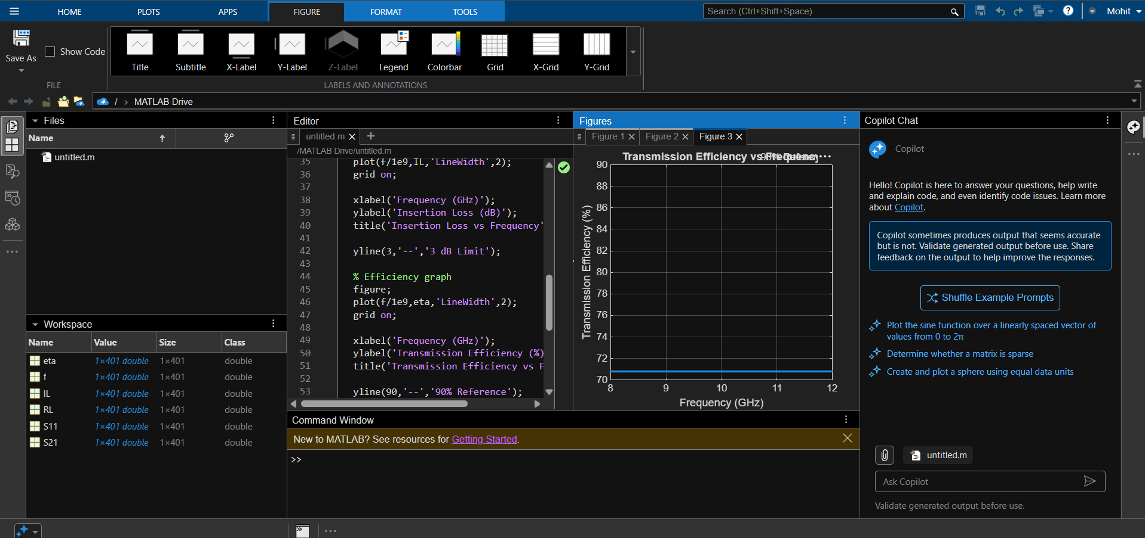
RESULTS:
The microwave transmission line and two-port network were successfully simulated over 8–12 GHz.
The 50 Ω characteristic impedance and propagation constant were determined, and the S-parameters $S_{11},S_{21},S_{12}$and $S_{22}$were analyzed.
The return loss, insertion loss and transmission efficiency were calculated from the S-parameters. The frequency corresponding to minimum reflection and maximum transmission was identified, verifying the transmission characteristics of the microwave network.

